Emotive Interjections

🔹 What Are Emotive Interjections?
# Source: AI Source: Provided by: [Data Path: Persons Table -> ID Column: 1, Name_En Column: Motasem Essam] -> From: [Chatgpt (GPT-4-turbo)] on [7/28/2025]
Emotive interjections are words or short phrases used to express strong emotions such as joy, anger, surprise, sadness, fear, pain, or excitement.
They are spontaneous reactions and stand alone from the grammatical structure of a sentence.

✅ Key Features
# Source: AI Source: Provided by: [Data Path: Persons Table -> ID Column: 1, Name_En Column: Motasem Essam] -> From: [Chatgpt (GPT-4-turbo)] on [7/28/2025]
- Express pure emotion
- Usually followed by an exclamation mark (!)
- Can occur at the beginning, middle, or end of a sentence
- Often used in spoken language or informal writing

🧩 Common Emotive Interjections
# Source: AI Source: Provided by: [Data Path: Persons Table -> ID Column: 1, Name_En Column: Motasem Essam] -> From: [Chatgpt (GPT-4-turbo)] on [7/28/2025]
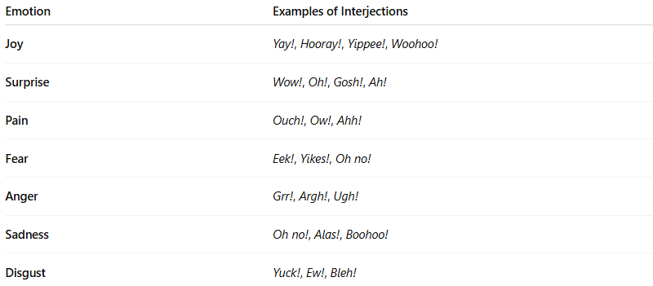
Emotion | Examples of Interjections
Joy | Yay!, Hooray!, Yippee!, Woohoo!
Surprise | Wow!, Oh!, Gosh!, Ah!
Pain | Ouch!, Ow!, Ahh!
Fear | Eek!, Yikes!, Oh no!
Anger | Grr!, Argh!, Ugh!
Sadness | Oh no!, Alas!, Boohoo!
Disgust | Yuck!, Ew!, Bleh!

📚 Example Sentences
# Source: AI Source: Provided by: [Data Path: Persons Table -> ID Column: 1, Name_En Column: Motasem Essam] -> From: [Chatgpt (GPT-4-turbo)] on [7/28/2025]
- Yay! We finally won the match! (joy)
- Ouch! That hurt! (pain)
- Oh no! I lost my wallet! (sadness/fear)
- Wow! That’s incredible! (surprise)
- Ugh! This traffic is terrible. (anger)

